Overarching RQ’s to keep in mind

1) What do people think about current conditions in regards to green space?
2) What existing programs to plant trees/fix houses exist?
3) How can we raise awareness of these programs? and "why has no one tried to fix philly?”

and Integrative Model to keep in mind (action: improving green spaces around Sayre/planting trees?)
- Attitudes, norms, self-efficacy, skills, barriers

Possible Questions:
- How satisfied are you with the amount of green space at Sayre right now? Or satisfied with a particular space?
- Do you use this space (e.g. breathing room, garden, playground)?
- Do you know about this space?
- How much time do you spend in this space?
- Why or why not do you spend time in this space?
- What makes it hard for you to spend more time in this space?
- How does this space make you feel when you are there?
- Do you feel this space is well taken care of?
- What would you like to see improve in this space?
- What would make you use this space more?
- What types of activities or events would you want to see happen here?

Other questions
- How important is it for you to have more green spaces such as trees, plants, and parks in your community?
- Do you think people in your community care about having green spaces?
- Do you know of any resources that could help you improve green spaces (such as tree planting services)?
- If you wanted to help improve green spaces in your community, how confident are you that you could find the tools, knowledge, or support to get started?
- Do you feel like your voice is heard when it comes to decisions about the environment in your Sayre?
- What would stop you from getting involved in a program to plant trees or improve green space in your community?
- Would you like to receive information about local programs that help with creating more green spaces?

Photovoice:
- Which photos should we put in the survey?
  - [link to student photos taken from photovoice activity]
- What other questions could we ask about these photos?

How does this photo make you feel? Looking at this photo, what’s one word that comes to mind?
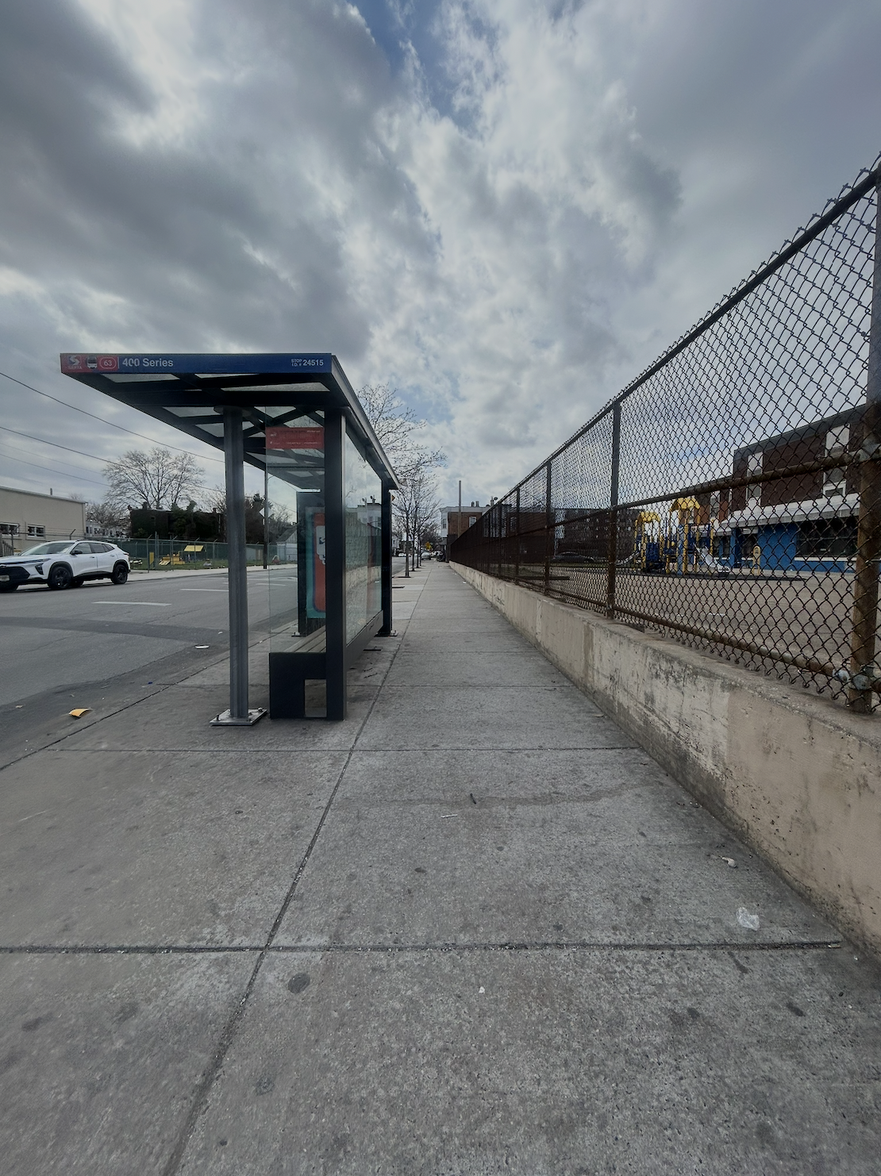

Idea generation of Sayre

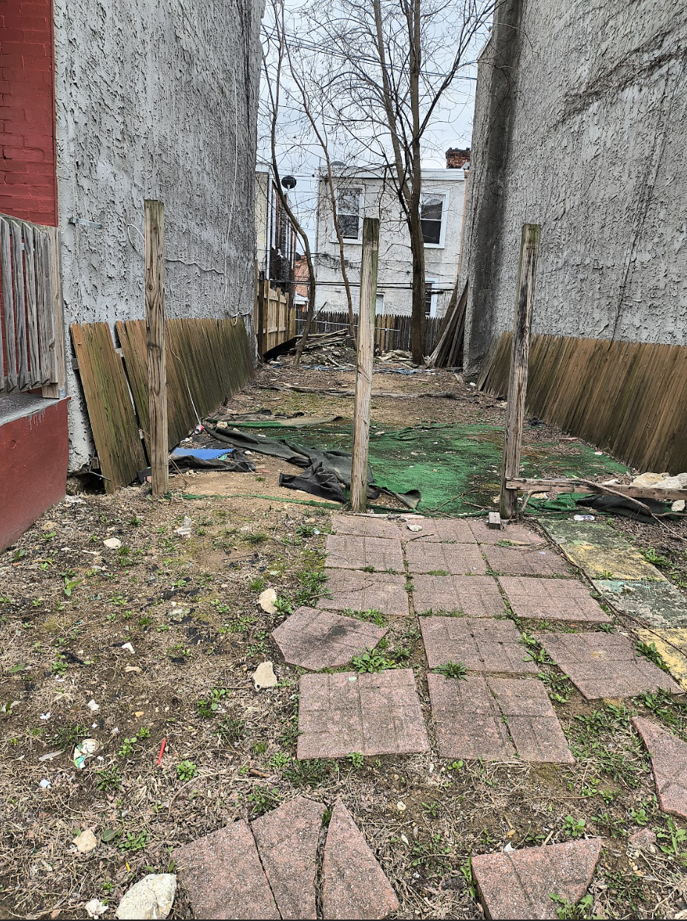
How does this photo make you feel?

